**Functional Requirements Template - Urban Hunt**Jonathan Petersen, Anthony Kiesel, Kenny Fryar-Ludwig, Hira Ahmed, Shawn Fairbourn, Kris Mygrant

**1. Introduction and Context**

This system is an extensible app for Android smartphones that allows users to connect and work together in real-time. The initial implementation of this app will be directed toward real-world games that are augmented by the use of this system. When players open the app, they have the ability to connect to other Urban Hunt users. The initial game mode will allow players to assign teams and set an objective.

This system will allow users playing games via phone to connect together like never before. It will bring a new digital dimension to classic outdoor games. Humans will no longer be able to lie that they haven't been infected by a zombie. Fitness users will be able to run faster and harder as they are chased by digital zombies. Users will learn about classic games and their rules that they may not have known the joy of before. Users will now be able to continue staring at their phone and get exercise at the same time.

This app addresses the problem of players keeping track of other night game colleagues. It also provides a solution to locating where team members may be, other members, locations of game play, and boredom.

**2. Users and their Goals**

**Actors:**

* Host User
* Client Users
* Google Maps
* Third-party “Multiplayer” server
* Android™ Smart Device (Phone/Tablet)

**Users:** Fitness Junkies, Android users, “Night Games” people

**Connected Systems:** MySQL server, Google Maps, Android Devices

**Use Cases:**

1. Play a variety of group games (Users)
   1. The humans can track team locations.
   2. The users may view tags and player status.
   3. The users can send/recv messages to/from team.
   4. They can also send/recv messages to/from all players.
   5. Users may view digital boundaries.
   6. Users may also view street map.
   7. The humans can view satellite map of local area.
   8. Users shall also update group on current objectives.
   9. Users can initiate game.
   10. Humans can save game state for future replay.
   11. Users can save list of commonly connected friends.
2. Track independent GPS stats (Google Maps)
   1. Google Maps will provide location data .
   2. Google Maps will track player movements.
3. Provide Sensory Feedback (Phone)
   1. The phone will give vibration Feedback.
   2. The phone will also play sound.
   3. The phone will also display Visual data
4. Server
   1. The server can store data.
   2. The server can send data.
   3. The server can receive data.

**Class Diagram**

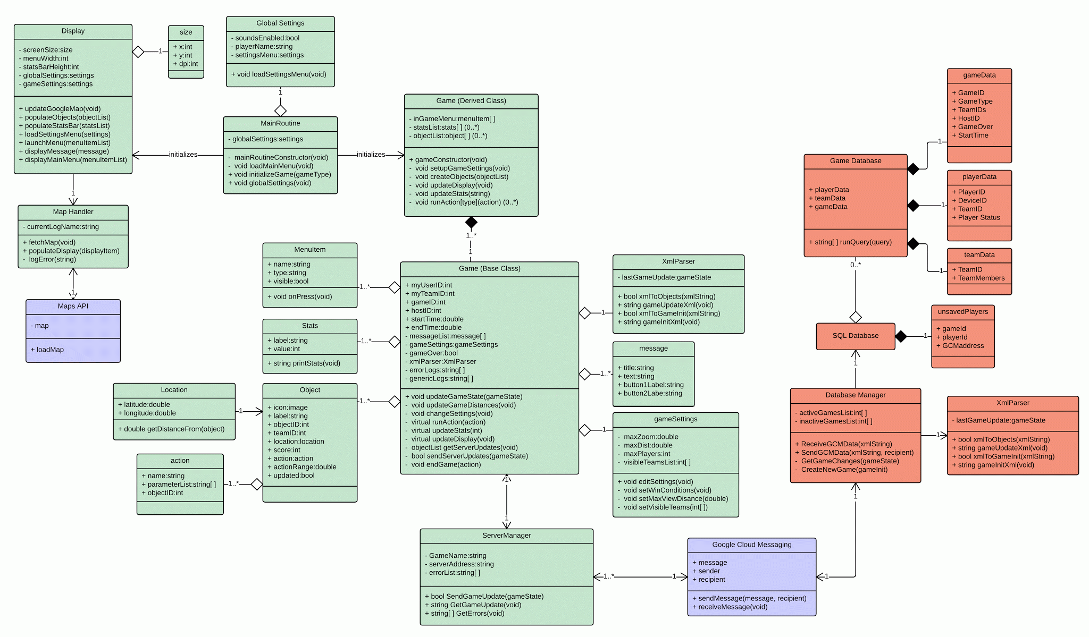

[*(Click image to expand)*](https://drive.google.com/file/d/0Bz5EFTIjkj7LUzhQUW9QZ0NST1k/view?usp=sharing)

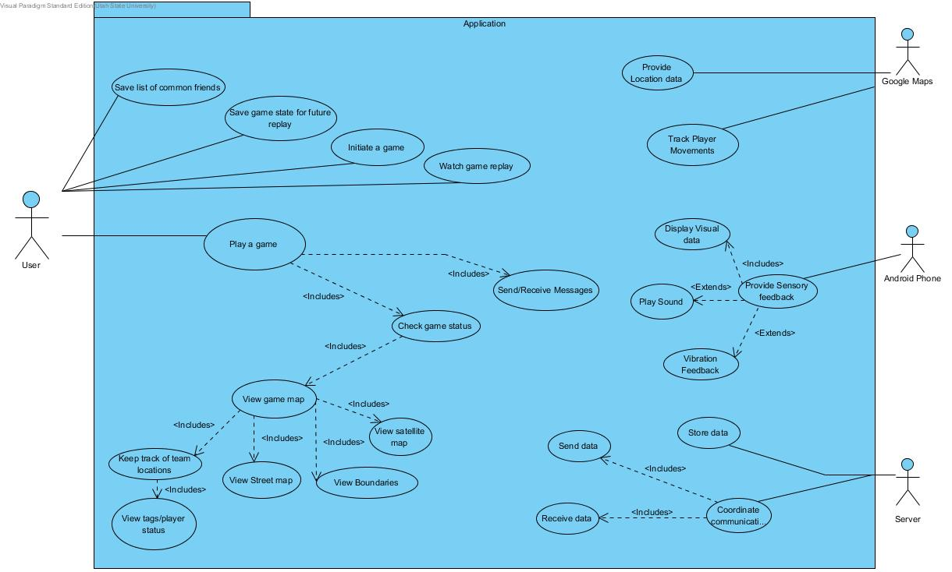

**3. Functional Requirements**

1. *Create a game*
   1. *The system will provide a screen that allows users to host a new game.*
   2. *The system will allow users to join an existing game*
   3. *The system will keep track of who is currently active in a given game*
2. *Play a game (Application)*
   1. *The system will provide a set of rules for specific types of games*
   2. *The system will display the location of other players*
   3. *The system will display the objectives of the current game*
   4. *The application will maintain a network connection component to talk to the location server*
   5. *Google Maps will determine actual location from GPS coordinates.*
   6. *The application will determine how users are interacting (collisions)*
3. *Location server to keep track of player location / data*
   1. *The location server can authenticate component to prevent cheating*
   2. *The location server can store data for Player Location*
   3. *The location server can store data for Player Teams*
   4. *The location server can store data for Games being played*
   5. *The location server can store data for messages / other misc information about a game*

**4. Non-functional Requirements**

1. *Our development will follow the Agile method, including weekly meetings.*
2. *The system will be regularly backed up, including backups on BitBucket/DigitalOcean*
3. *Any changes made to the project will have to be unanimously voted on.*
4. *The application will provide reasonably responsive GPS location for all players*
5. *The application should be functional on all supported Android platforms.*
6. *The system will be accurately documented in code and in the application/comments*
7. *The system will be capable of supporting an arbitrary number of users*
8. *The system will be able to support users globally*

**5. Future Features**

*We may implement powerups such as temporary invulnerability or long-range projectile tagging.*

*We may implement Facebook integration to find friends playing games or invite others to a current game.*

*We may implement game-specific achievements so that users who play better or more frequently can be recognized at a glance.*

*The system will provide an AI component to simulate other players*

*The application will provide a splash screen to keep already whipped user engaged.*

*Keep Statistics about current / past games (Fitness Users)*

*Fitness users can keep stats on local storage of distance travelled (calories burned?).*

*Fitness users may keep stats on feature to replay the locations of users after completion of a game.*

*The system will provide an engine to provide that set of rules to current players.*

*The system will determine when a game is finished.*

*The system will record the current location of players from their phone.*

*The application will have the capability to save game data to resume play later.*

*The phone will provide sensory feedback (Visual, audio, haptic) based off of game status.*

*The system will provide verification that users play by the rules.*

*The player’s applications will receive messages from the host of the game.*

**6. Glossary**

GPS - Global Positioning System

Game - A set of objectives for users to complete

Android Phone - Device running Android OS with GPS functionality.